23CSE111 OBJECT ORIENTED PROGRAMMING
S2 B.Tech CSE
Department of Computer Science and Engineering
Amrita School of Computing, Amritapuri Campus
CASE STUDY
PHASE – 2 (Design)
Architectural Modelling (CO2)

Group No : 9
Team Members :
Roll No | Student Name
Am.sc.u4cse25262 | Nithilan S
Am.sc.u4cse25239 | Nithish Kumar Saravanan
Am.sc.u4cse25253 | Sujeeth S
Am.sc.u4cse25215 | Dharun A

- Problem Title : 29) Gym Membership Management System

STRUCTURAL DESIGN
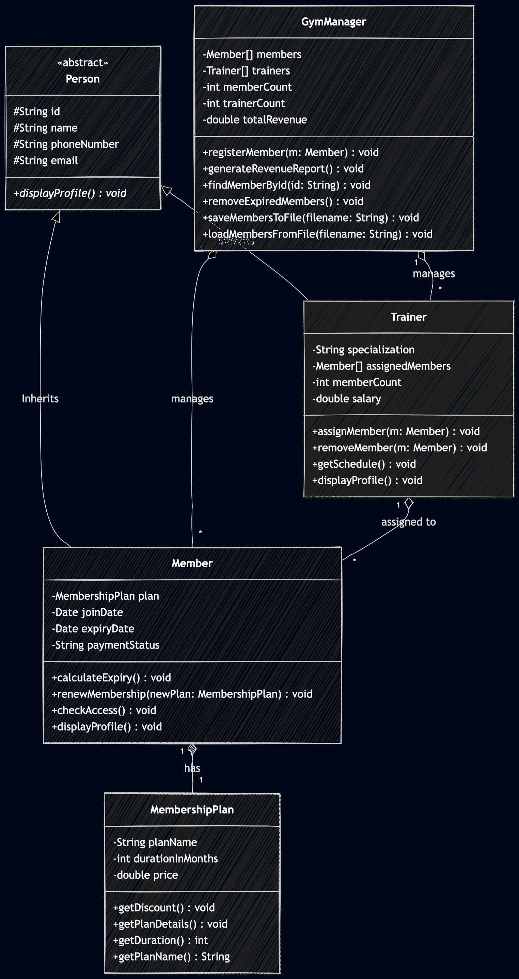
- Class diagram (draw class diagram that shows different classes and their relationships. Use UML notations)

BEHAVIUORAL DESIGN
- Use-case diagram
- List of actors
- Members
- Trainers
- Manager

- List of use-cases
- Add members and trainers accessible only by manager.
- Members choose their membership plan
- Trainers give assistance.

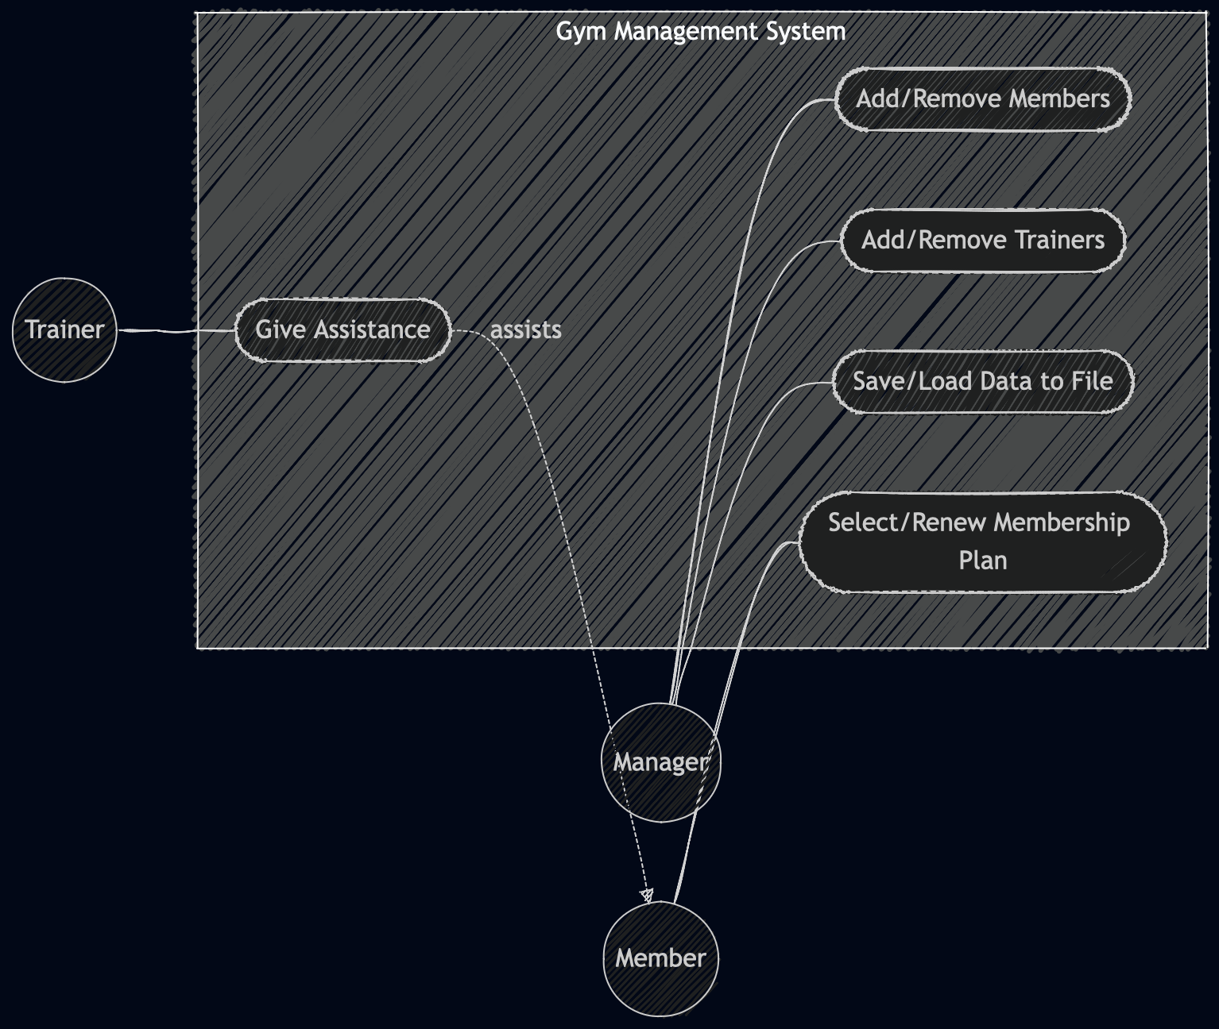
- Use case diagram (use UML notations)

- Sequence diagram (use UML notations)
  - Choose key use cases and draw their sequence diagram. First describe the scenario in few sentences. Then draw the sequence diagram.

Scenario 1: Manager Registers a New Member

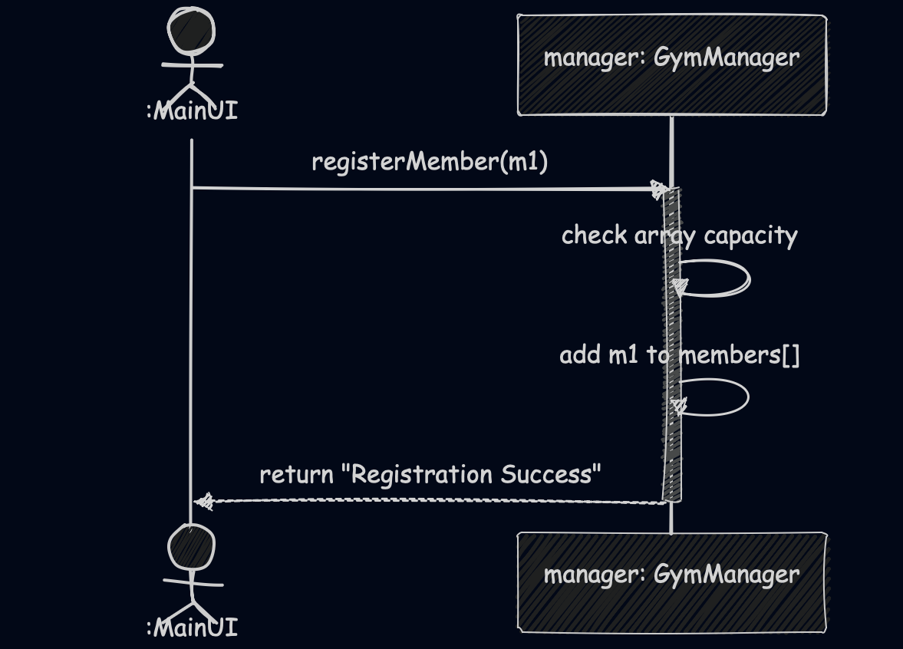
Description: In this scenario, the main system interface passes a newly created Member object to the GymManager. The manager takes this object, processes it, and stores it inside its internal members array, successfully completing the registration.

  - Choose key use cases and draw their sequence diagram. First describe the scenario in few sentences. Then draw the sequence diagram.

Scenario 2: Member Chooses/Renews a Membership Plan

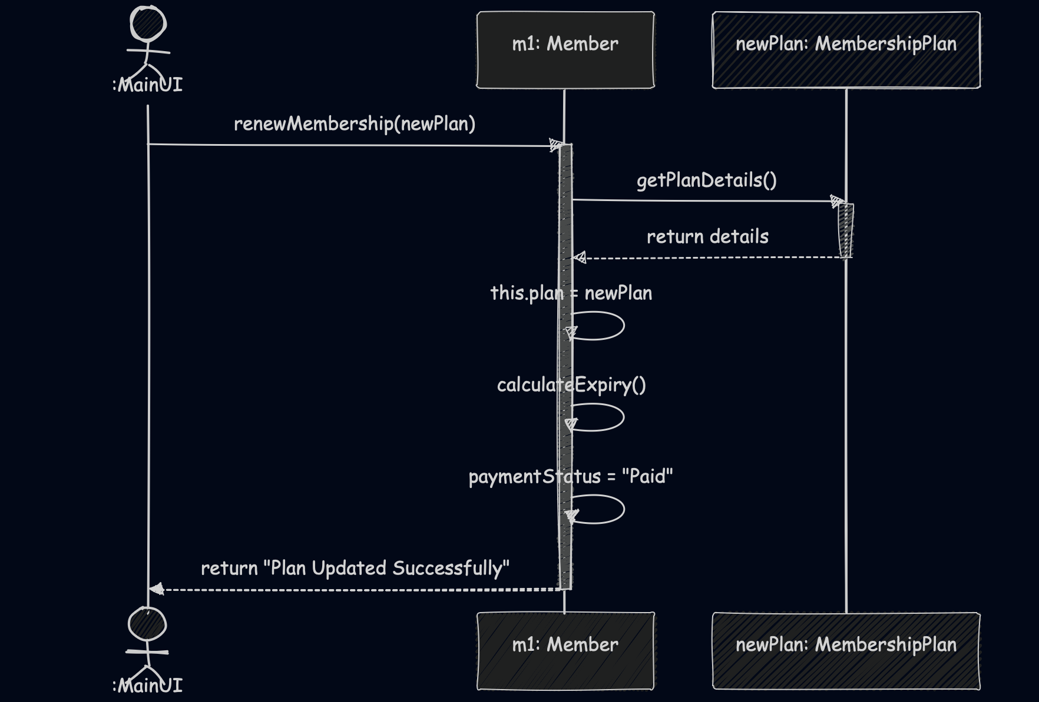
Description: In this scenario, a new MembershipPlan is selected for an existing Member. The Member object updates its internal plan attribute, triggers a method to recalculate its expiryDate based on the plan's duration, and updates its payment status.
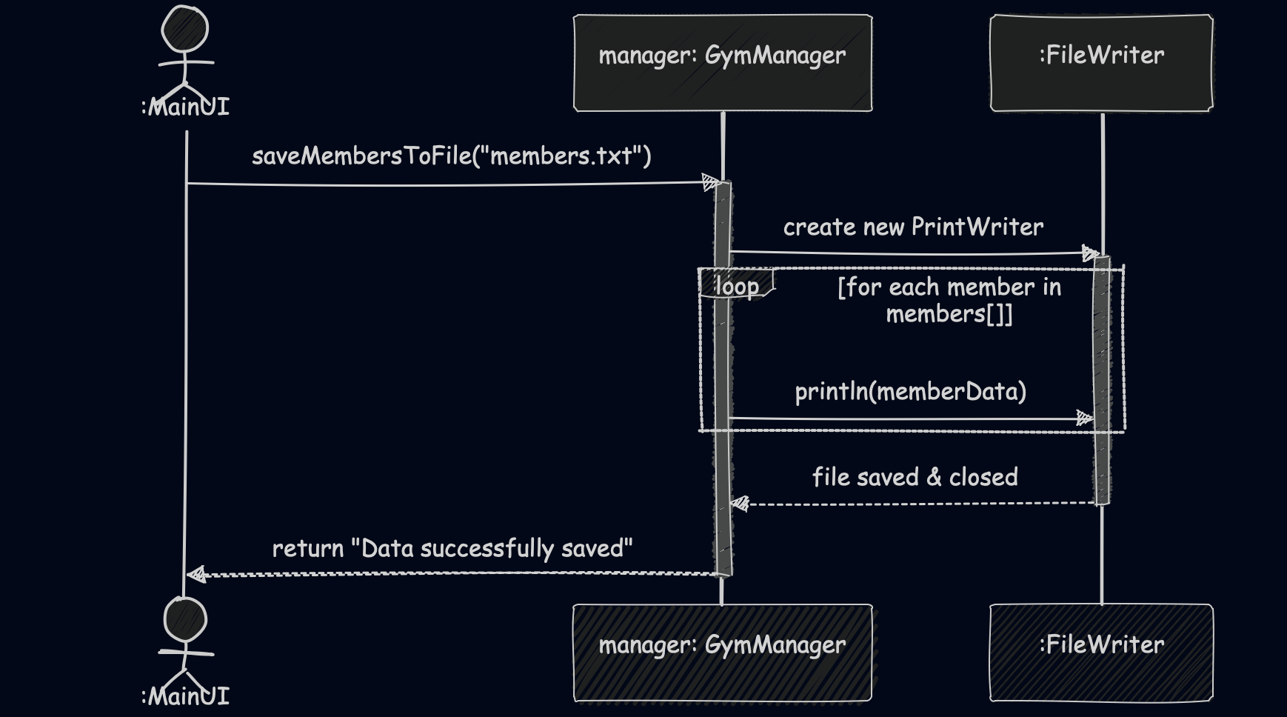
Scenario 3: Manager Saves Data to File

